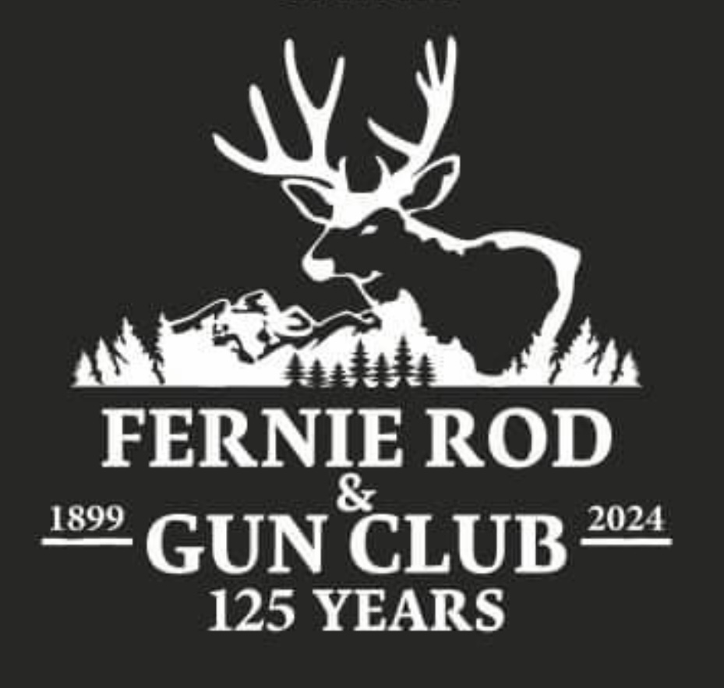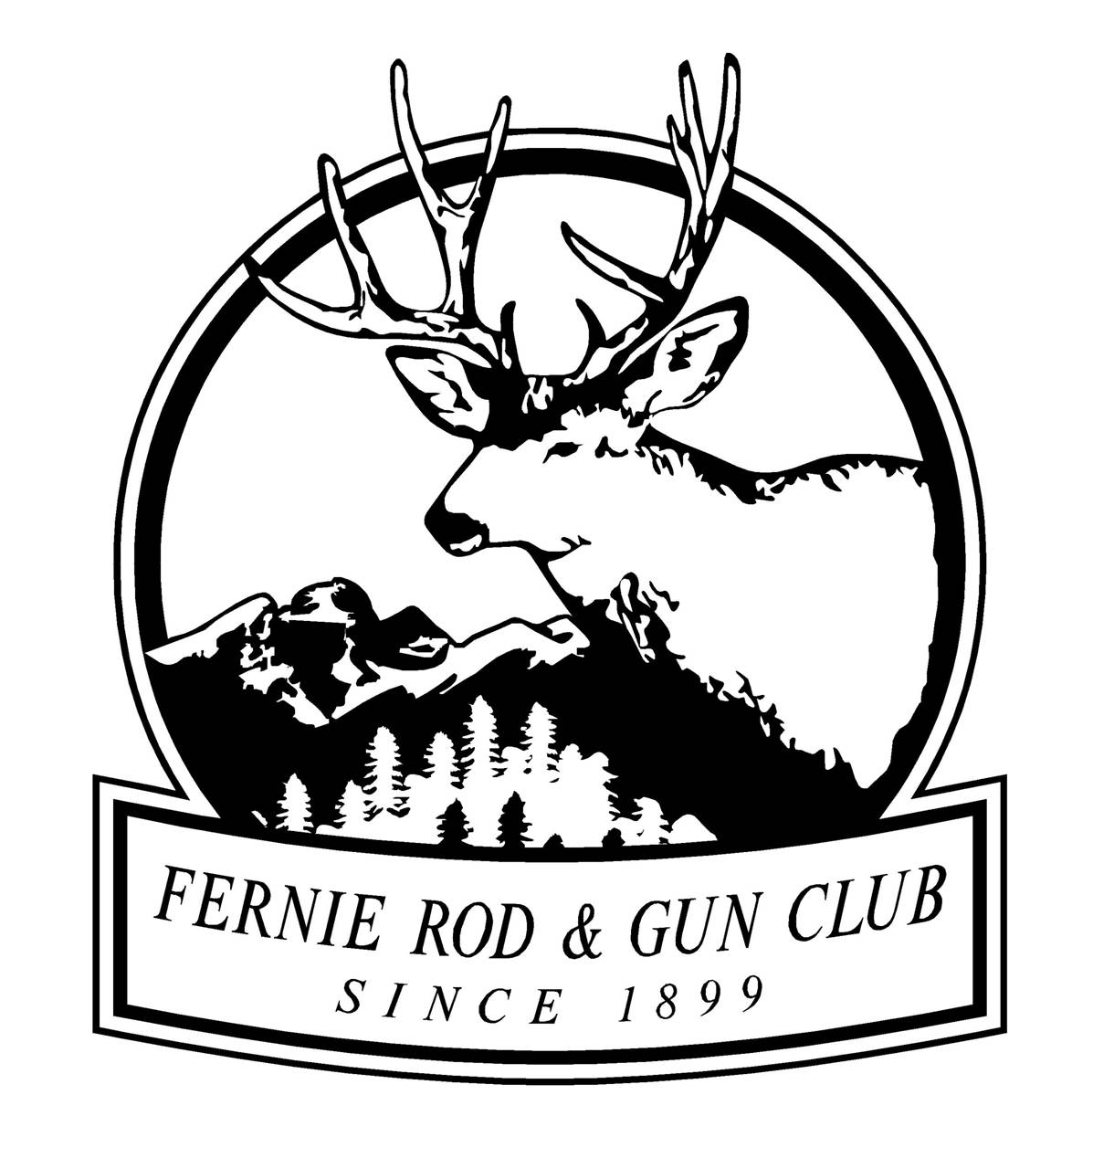

Re: Fernie Rod & Gun Club Wigwam Flats Ecosystem Enhancement Project 2025-2029

Fellow Outdoor Enthusiasts,
The Fernie Rod & Gun Club is happy to announce that the Club’s “Wigwam Flats Ecosystem Enhancement Project” has been approved by the Columbia Basin Trust to move to the final step in the application process. We are currently developing a final application and workplan to confirm project details with CBT to secure $750,000 from them. We are now exploring additional partnerships to find an additional $489,000 to allow for the project to reach its full ambitious.
The FRGC has been involved with habitat conservation for many decades and has performed numerous projects in the Wigwam Flats area over the years and continues to this day. The area has seen decreases in adequate habitat for ungulates due to forest encroachment in a period of fire suppression. This project will take habitat conservation to the next level as it will be a five-year project dedicated to restoring hundreds of hectares of land through slashing, spraying, and seeding, as advised by BC WLRS prescriptions. Wildlife studies will also be incorporated into the project to monitor the effectiveness of the restoration work, evaluating habitat quality and relative ungulate abundance.
This projected budget for this five-year project will be a minimum of 1.239 million dollars. The majority of the funds will be used for on-ground results. The FRGC has partnered with Columbian Basin Trust and if the final workplan and budget is approved CBT will fund a maximum of $750,000 towards the project. The FRGC must show on the application the confirmation of the remaining funds needed for the project along with all other partners and contributors. The club has been informed by the Nature Conservancy of Canada (NCC), Nature Trust (NT), East Kootenay Invasive Species Council (EKISC), and Yaq̓it ʔa·knuqⱡi 'it First Nation that they support the project.
The FRGC would like to partner with everybody that would like to support the project. If you want to be a large or small contributor, a partner, or somebody that would like to provide in-kind help please let us know.
Donation Tiers – Total donations over the five-year period: -
Bronze Level: Up to $10000
Silver Level: - $10, 001-$50,000 Gold Level: - $50,001 - $250,000 Platinum Level: - $250,001+
The FRGC has committed $25,000 for the five-year project and will continue to have slashing work parties in the project area each year.
All contributors will be acknowledged on all FRGC Social Media Sites, Project Boards at Site and one at the FRGC Range, and in all news articles and news releases.
For more information and donation information please contact:
FRGC President: Kevin Marasco (President@ferniergc.com)
FRGC WFEEP Committee: Joe Caravetta (Co-Chair), Dave Roberts (Co-Chair), George Wilson, Landon Kubos, Kevin Roberts, Aaron McDonald, Richard Edmundson
Yours in Conservation,
FRGC WFEEP Committee

